spring boot unit tests

.6. developing unit tests – overview

..add dependency for junit
org.junit.jupiter

..create similar package structure under /test
.java
..test
...com.ucaru.demo
....main

..phases of unit test
setup
execute
assert

@Test
void testEquals()
{
//set-up
DemoUtils demo = new DemoUtils();
//execute
int actual = demo.add(1,9);
//assertions
Assertions.assertEquals(actual, 10, “assert is failed”);
}

tests will run automatically
test class don’t have to be public

.7. JUnit Assertions

import static org.junit.jupiter.api.Assertions.*

assertEquals
assertNotEquals
parameters -> (expected,actual, errorMessage)
assertNull
assertNotNull
parameters -> (actual, errorMessage)

.9. lifeCycle Methods

@BeforeEach
runs before every test case
@AfterEach
runs after every test case
class DemoTest()
{

DemoUtils demo;

@BeforeEach
void instantiateDemo()
{
demo = new DemoUtils();
sout(“demo is instantiated”);
}
@AfterEach
void after() { sout(“test is finished”); }
}

@BeforeAll
runs only once before all test methods (by default must be static)
(to connect database, create threads, etc)
@AfterAll
runs only once after all test methods (by default must be static)
(to release database, threads, etc)

.11. custom names for tests

@DisplayName(“Null and Not Null”)

..name generators
(on class level)
@DisplayNameGeneration(DisplayNameGenerator.Simple.class)
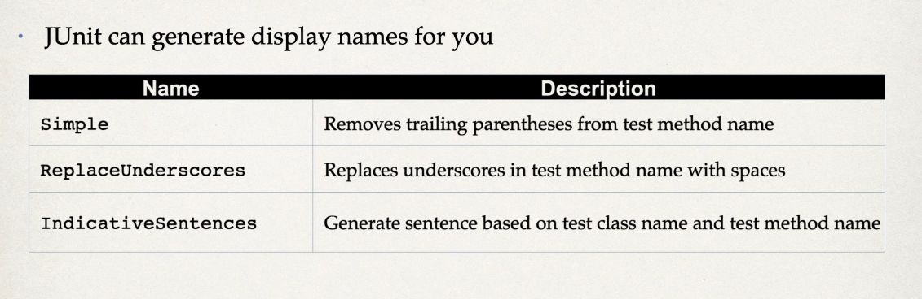

no need to add display annotation to each function

.13. and .14. Same and NotSame, assertTrue, assertFalse

Assertions.assertSame(obj1, obj2, “message”);
Assertions.assertNotSame(obj1, obj2, “message”);

same and not same runs with respect to object references

Assertions.asserTrue(result, “message”);

.15. arrays, iterable and lines

assertArrayEquals(list1,list2 ,”message”)
checks if two arrrays are equal

assertIterableEquals(list1,list2, “message”)
checks if the each of element of two iterables are equal

assertLinesMatch(list1,list2,”message”)
checks list of strings

.16. assertThrows and timeouts

assertThrows(Exception.class, () -> { function(); }, “message”);
checks if function throws expected type of the exception

assertDoesNotThrow( () -> { function(); }, “message”);

assertTimeoutPreemptively(Duration.ofSeconds(3), () -> {}, “message”)
checks whether function completes before stated time or not

.20. order of the tests

in general order should not be a factor in unit tests
tests should run independently

but for various reasons it might be a need for tests to run in order

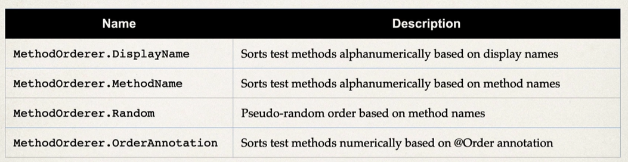

@TestMethodOrderer(MethodOrderer.DisplayName.class)
@TestMethodOrderer(MethodOrderer.MethodName.class)
(class level annotation)

@Order : lowest number has the most priority, negative values are allowed

@Order(3)
method level annotation

.29. conditional tests

@Disabled(“message”)
test methods with disabled does not run but show up on coverage reports

@EnabledOnOs(OS.Windows)
@EnabledOnOs({OS.Windows,OS.MAC})
only runs on given environment

@Test
@EnabledIfSystemProperty(named=”PROP”, matches=”CI_CD”)

@Test
@EnabledIfEnvironmentVariable(named=”ENV”, matches=”dev”)

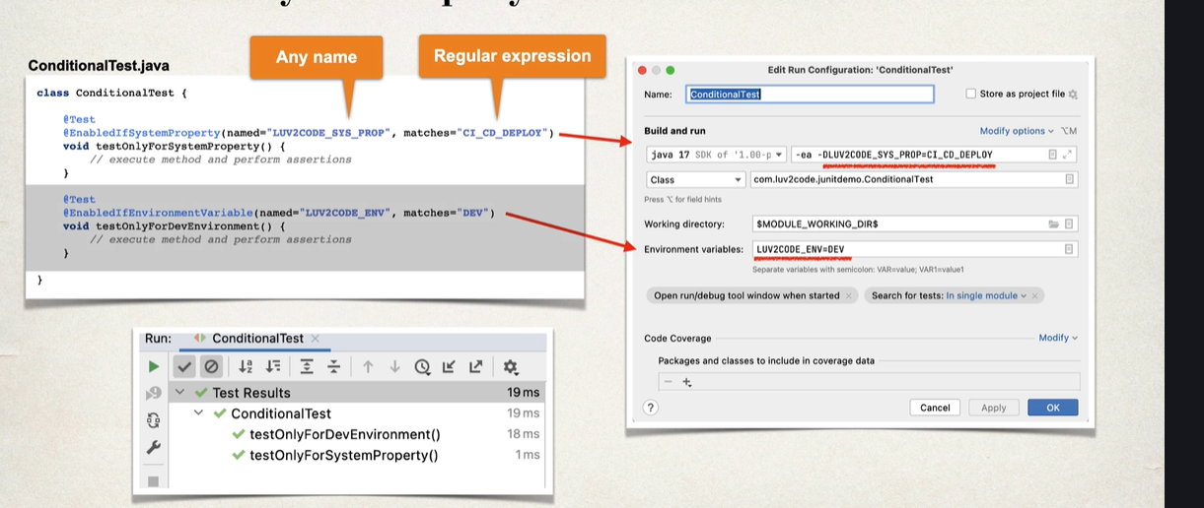

ep.2 test driven development

.32. test driven development

in general, development process is:
task -> code -> test(optional)

in a test driven development process starts with writing a test (knowing that it will fail), then code is developed until it passes the test. then it is refactored, and tested again. then next cycle starts. it is a cycled process

.37. parameterized tests
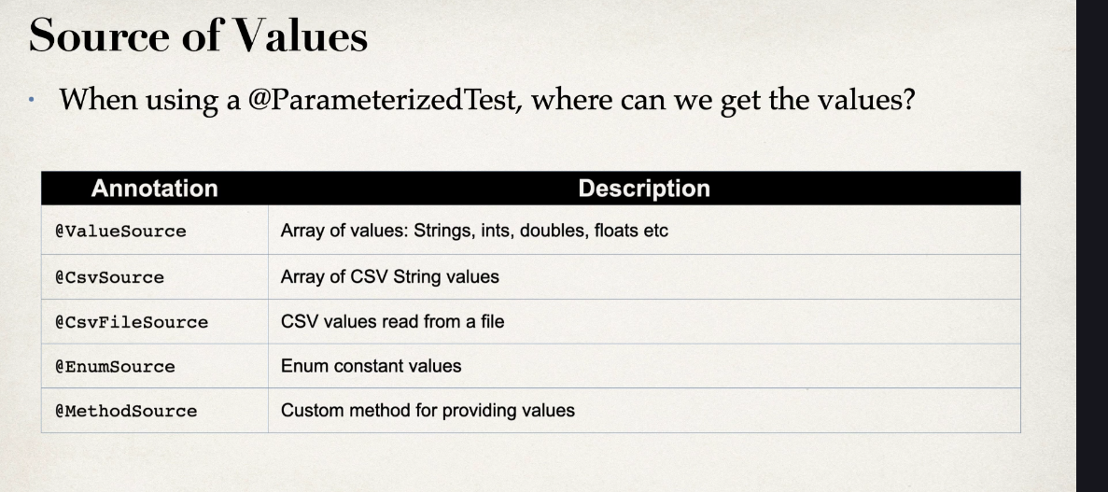
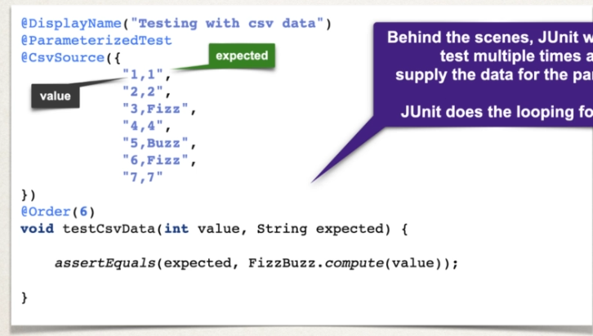

@ParameterizedTest(name=”value = {0}, expected = {1}”) <- for messages

@CsvFileSource(resources = “/test_data.csv”)
to read from file (file is in test/java/resources folder)

reminder that when new file is added it is essential to rebuild project

ep.3 spring boot unit testing support

.41. overview
in order for spring boot to run tests properly, it needs:
access to the spring app context
spring for dependency injection
retrieve data from application.properties
mock support
which can be provided only using @SpringBootTest

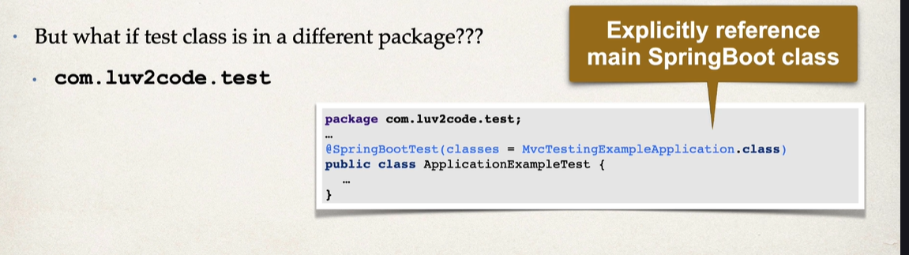

.43. add dependency and configure first simple test class

spring-boot-starter-test (includes jUnit)

if names of packages are the same in main and test, spring should automatically find application class. but if its different, use:

@SpringBootTest(classes = MyMainApplication.class)

